HE3001 Tutorial 10 Solutions

1) Mighty Soft software company is about to introduce a new computer operating system called DoorKnobs. As swapping files is easier with people who have the same operating system, the amount people are willing to pay for DoorKnobs is greater the larger they believe DoorKnobs’s market share to be.
The perceived market share for DoorKnobs is the fraction of all computers that the public believes is using DoorKnobs. When the price of DoorKnobs is $p$, then its actual market share is the fraction of all computer owners that would be willing to pay at least $$p$ to have DoorKnobs installed on their computers.
Market researchers have discovered that if DoorKnobs’ perceived market share is $s$ and the price of DoorKnobs is $$p$, then its actual market share will be $x$, where $x$ is related to the price $p$ and perceived market share $s$ by the formula
$p=256s(1-x)$ (1)
In the short run, Mighty Soft can influence the perceived market share of DoorKnobs by marketing strategies. In the long run, the truth will emerge, and DoorKnobs’ perceived market share $s$ must equal its actual market share $x$.
(a) If the perceived market share is $s$, then the demand curve for DoorKnobs is given by Equation (1). Draw the demand curve relating price to actual market share in the case in which DoorKnobs’s perceived market share is $s=1/2$. Label this curve $s=1/2$
The (inverse) demand curve is $p=128(1-x)$
See Figure 1.
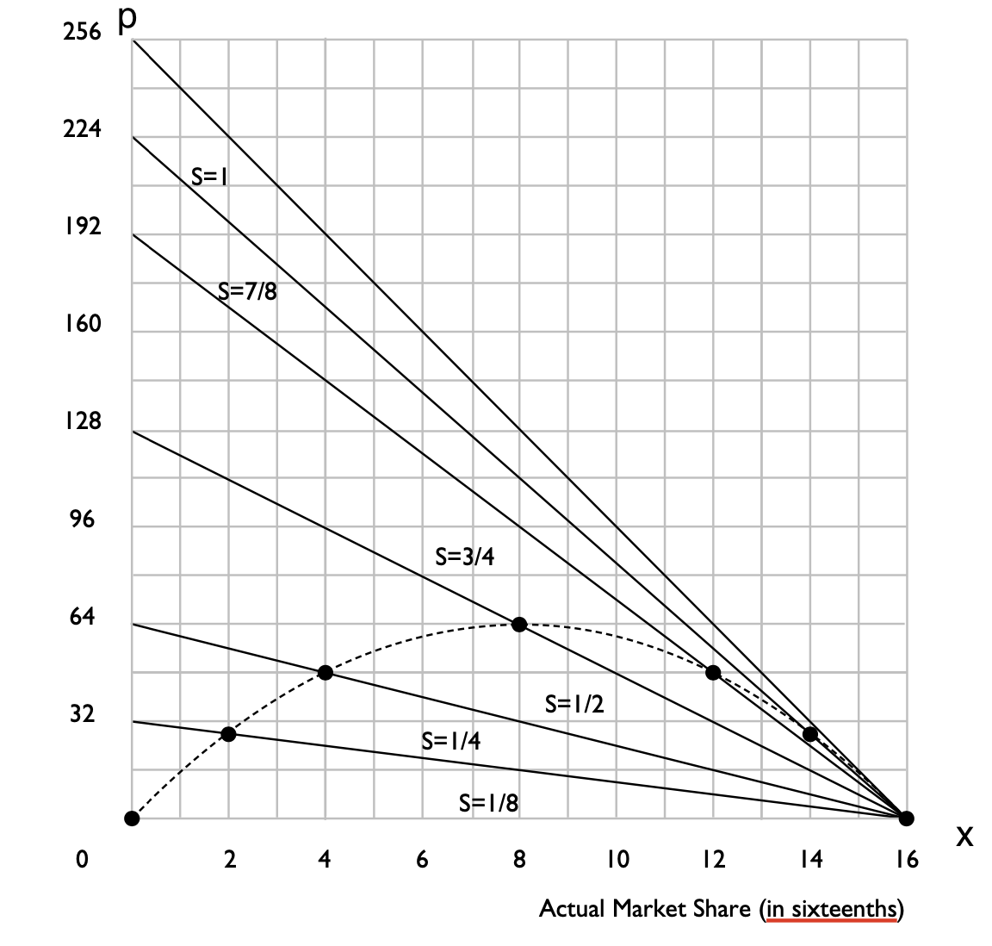
Figure 1. Demand curve relating price (p) to actual market share (x)

(b) On the demand curve that you just drew with $s=1/2$, mark a dot on the point at which the actual market share of DoorKnobs is 1/2. What is the price at which half of the computer owners actually want to buy DoorKnobs, given that everybody believes that half of all computer owners want to buy DoorKnobs?
See Figure 1. (The point is on the demand curve $s=1/2$ with x=1/2)
p= 256 * 1/2 *1/2= 64

(c) On the same graph, draw and label a separate demand curve for the case where DoorKnobs’s perceived market share $s$ takes on each of the following values: $s=1/8, 1/4, 3/4, 7/8, 1$. Just as in part b), mark the points at which actual market share takes these values, showing the respective prices at which the actual market share is $s$.
Repeat steps a) and b) for all the different values and see Figure 1 for illustration.

(d) Let us now draw the long-run demand curve for DoorKnobs, where we assume that computer owners’ perceived market shares $s$ are the same as the actual market shares $x$. If this is the case, it must be that $s = x$, so the inverse demand curve is given by $p=256x(1-x)$. On the graph above, plot a few points on this curve and sketch in an approximation of the curve. (Hint: the curve you draw must go through all the points that you have already plotted.)
See dotted line in Figure 1.

(e) Suppose that Mighty Soft sets a price of $48 for DoorKnobs and sticks with that price. There are three different perceived market shares such that the fraction of consumers who would actually want to buy DoorKnobs for $48 is equal to the perceived market share. One such perceived market share is 0. What are the other two possibilities?
Solve for $48=256s\left(1-x\right)$ with $s = x$
$$s=\frac{1}{4}or\frac{3}{4}$$

2) Suppose that we have 100 consumers in market A and 500 consumers in market B.
The consumers have different preferences for the good with consumer $i$ in market A having $v_{i}^{A}=i$ and a consumer $j$ in market B having $v_{j}^{B}=j$.
A consumer’s valuation of good A depends on how many people adopt good B, $n_{B}v_{i}^{A}$.
A consumer’s valuation of good B depends on how many people adopt good A ,$n_{A}v_{j}^{B}$.

(a) Solve for the inverse demand curve of good A: $p_{A}$ as a function of $n_{A}$ and $n_{B}$.
(b) Solve for the inverse demand curve of good B: $p_{B}$ as a function of $n_{A}$ and $n_{B}$.
Let $i$ be the marginal consumer in market A.
Let $j$ be the marginal consumer in market B.
Number of consumers in each market is given by:
$$n_{A}=100-i+1=101-v_{i}^{A}$$
$$n_{B}=500-j+1=501-v_{j}^{B}$$
The valuation of the marginal consumer in each market (the inverse demand) is given by
$$p_{A}=n_{B}v_{i}^{A}$$
$${p_{B}=n}_{A}v_{i}^{B}$$

$$p_{A}=n_{B}(101-n_{A})$$
$$p_{A}=n_{A}(501-n_{B})$$

Suppose that the marginal cost of good A is 10000 and the marginal cost of good B is 4000 and that the market expands whenever willingness to pay exceeds marginal costs.
(c) Write an equation which shows the values of $n_{A}$ and $n_{B}$ for which $n_{A}$ in market $A$ will not change.
$$n_{B}\left(101-n_{A}\right)=10000$$

(d) Write an equation which shows the values of $n_{A}$ and $n_{B}$ for which $n_{B}$ in market $B$ will not change.
$$n_{A}\left(501-n_{B}\right)=4000$$

(e) Use (c) and (d) to sketch out the dynamics of $n_{A}$ and $n_{B}$ in a diagram and label all the stable and unstable equilibria.
$n_{A}$ increases (decreases) when $n_{B}\left(101-n_{A}\right)>\left(<\right) 10000$ or $n_{B}>(<)\frac{10000}{101-n_{A}}$
$n_{B}$ increases (decreases) when $n_{A}\left(501-n_{B}\right)>\left(<\right) 4000$ or $n_{B}<\left(>\right) 501-\frac{4000}{n_{A}}$

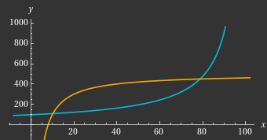
There are 3 equilibria, 2 stable (red) and 1 unstable (blue)

3) Intoot sells a program, Fasten for $50 to users which includes a one month subscription. The monthly maintenance costs for Intoot are $20 per user and it sets a subsequent subscription fee at cost to users. Consider each month as 1 period.
Suppose that a consumer purchases Fasten for $50 in period 1 and spends $20 on subscription in each subsequent period. Assume for simplicity that the consumer uses the program for an infinite number of periods.
(a) If the interest rate is r = .10 per period, what is the present value of the stream of payments made by the consumer?
$$50+\frac{20}{1+r}+\frac{20}{{(1+r)}^{2}}+\frac{20}{{(1+r)}^{3}}+…$$
$$50+\frac{20}{r}=250$$

Intoot’s competitor sells an equally effective product called Czechwriter. The Czechwriter program also sells for $50 (including a one-month subscription) and has a subscription fee of $20 per period.
(b) Intoot is contemplating to announce a rise in its subscription fee to $30 per period in the next month. If so, will its customers cancel their Fasten subscription now (before they are charged) and immediately switch to Czechwriter? Explain.
Yes, the present value of cost of continuing to use Fasten is $20+\frac{30}{1+r}+\frac{30}{{(1+r)}^{2}}+\frac{30}{{(1+r)}^{3}}+…=320$, while the present value of costs of switching to Czechwriter are $50+\frac{20}{1+r}+\frac{20}{{(1+r)}^{2}}+\frac{20}{{(1+r)}^{3}}+…=250$.

(c) Suppose that instead Intoot contemplates raising its to $22 per period in the next month. Will its customers switch now?
No. The present value of cost of continuing to use Fasten are $20+\frac{22}{1+r}+\frac{22}{{(1+r)}^{2}}+\frac{22}{{(1+r)}^{3}}+…=240$
while the present value of costs of switching to Czechwriter are 250.

(d) At what price for checks will Intoot’s customers just be indifferent to switching now?
The present value of costs of continuing to use Fasten are $20+\frac{x}{1+r}+\frac{x}{{(1+r)}^{2}}+\frac{x}{{(1+r)}^{3}}+…=20+x/r$
the present value of costs of switching to Czechwriter are 250.
$$20+\frac{x}{r}=250$$
$$x=23$$

(e) If Intoot charges the highest price that it can without making its customers switch, what profit does Fasten make on checks from each of its customers per period? What is the present value of the profit per customer that Fasten gets if it sets the price of checks equal to the number determined in the last question? How does this compare to the customer switching cost?
Profit per period = $23-20=3$
PV in future periods, after prices have changed =$\frac{3}{1+r}+\frac{3}{{(1+r)}^{2}}+\frac{3}{{(1+r)}^{3}}+…=30$
Notice that this is exactly equal to the switching costs which customers incur in the current period: $50-20$.

Note that under the assumptions of this specific model, profits= switching cost. It shows that switching costs allow firms to have positive profits even with perfect competition.

4) Consider Software X version 1, published by ABC which will be sold for two years, until version 2 comes out. The software is locked with encryption such that each copy bought can only be used by 1 user at any time.
Let $p_{1}$ be the price charged for copies sold in the first year and let $p_{2}$ be the price charged for copies sold in the second.
Everyone is aware that there will be an active market for used copies after one year and that used copies of version 1 will have zero resale value when the new version is released after 2 years. At the end of the first year, owners can resell their copies to the software store for 40% of the second-year price, $p_{2}$.
The demand in the first year is thus a function of the net costs: $q_{1}=D_{1}(p_{1}-0.4p_{2})$.
After the first year, owners may decide to keep their copies for future use. The number of copies kept is given by a keeper’s demand which depends on the resale price: $D^{k}(0.4p_{2})$.
For simplicity, let us assume that new and used software cost the same in the software store in the second year, and that students are indifferent between them. As copies bought in the second year have zero resale value, the demand for software in the second year is thus only a function of its price: $q_{2}=D_{2}(p_{2})$.
(a) Write an expression for the number of new copies that ABC can sell in the second year after publication if it sets prices $p_{1}$ in year 1 and $p_{2}$ in year 2.
Number of new copies= $D_{2}\left(p_{2}\right)-{[D\left(p_{1}-0.4p_{2}\right)-D}^{k}(0.4p_{2})]$. The term in square brackets is the number of consumers who purchase in year 1 and sell their copies in year 2.
(b) Write an expression for the total number of new copies that ABC can sell over two years at prices $p_{1}$ and $p_{2}$ in years 1 and 2. Would the total number of copies sold change if $p_{1}$ increases and $p_{2}$ remains constant?
Total over 2 years $={D_{1}\left(p_{1}-0.4p_{2}\right)+D}_{2}\left(p_{2}\right)-{[D\left(p_{1}-0.4p_{2}\right)-D}^{k}(0.4p_{2})]$
Simplifying, we get: $D_{2}\left(p_{2}\right)+D^{k}(0.4p_{2})$ which is independent of $p_{1}$.
Hence, total copies will not change if $p_{1}$ increases and $p_{2}$ is constant.

(c) Assume that ABC only makes money from the sale of new copies. Suppose that marginal costs are fixed per unit at $c$. Write out an expression for the profits of ABC.
Total profits $D_{1}\left(p_{1}-0.4p_{2}\right)\left(p_{1}-c\right)+ {\{D}_{2}\left(p_{2}\right)-{[D\left(p_{1}-0.4p_{2}\right)-D}^{k}(0.4p_{2})]\}(p_{2}-c)$

Let $D_{1}(p_{1} - 0.4p_{2}) = 100 (90 - p_{1} + 0.4p_{2}); D_{2}(p_{2}) = 100(90 - p_{2}); D_{k}(0.4p_{2}) = 100(90 - 0.8p_{2})$. Marginal costs, $c=10$.
(d) What are the prices $p_{1}$ and $p_{2}$ that will maximise ABC’s total profits over the 2 years?
From c) and substituting the equations above,
Total profit$=100 \left(90 - p_{1} + 0.4p_{2}\right)\left(p_{1}-c\right)+\{100(90 - p_{2})-[100 \left(90 - p_{1} + 0.4p_{2}\right)-100(90 - 0.8p_{2})]\}(p_{2}-c)$
Simplifying, we get: $100\left(90 - p_{1} + 0.4p_{2}\right)\left(p_{1}-c\right)+100\{p_{1}-2.2p_{2}+90\}(p_{2}-c)$
$$=100\left(90p_{1}-p_{1}^{2}+0.4p_{1}p_{2}-90c+p_{1}c-0.4p_{2}c+p_{1}p_{2}-2.2p_{2}^{2}+90p_{2}-cp_{1}+2.2p_{2}c-90c\right)$$
$$=100\left(90p_{1}+108p_{2}-p_{1}^{2}+1.4p_{1}p_{2}-2.2p_{2}^{2}-1800\right)$$
From the first order conditions, we have:
- $90-2p_{1}+1.4p_{2}=0$
- $108+1.4p_{1}-4.4p_{2}=0$
Substituting (1) into (2) will give:
$$108+1.4\left(45+0.7p_{2}\right)-4.4p_{2}=0$$
$$3.42p_{2}=171$$
$$p_{2}=50$$
$$p_{1}=80$$

(e) Suppose that ABC now wants to charge the same price in both years. What is the price that will maximise its total profits and what will be the quantities sold in each year?
If it charges a price $p$ in both years, then total profits$=$
$$100\left(90p+108p-p^{2}+1.4p^{2}-2.2p^{2}-1800\right)$$
$$=100(198p-1.8p^{2}-1800)$$

From the FOC, $198=3.6p$, $p=55$
New sales in Year 1 is $5700$. New sales in year 2 is 3500. Resale in year 2 is 1100.

(f) Suppose that ABC decides instead to release an intermediate version after the first year which eliminates the resale market. Hence, $D_{1}(p_{1}) = 100 (90 - p_{1})$, $D_{2}=100(90 - p_{2})$. Suppose that ABC again charges the same price in both years. What is the price that will maximise its total profits and what will be the quantities sold in each year?
Since resale is not possible, total demand is just $200(90-p)$. Profits$=200(90-p)(p-10)$
From the FOC, $90-p+10-p=0$
$$p=50.$$
Quantity in each year is $4000$

(g) If ABC wants to charge the same price in both years, would it be better for ABC to release an intermediate version or not?
Profits in part e) is 364500.
Profits in part f) is 320000.
Hence ABC should not release an intermediate version.

Practice
Suppose that demand for DoorKnobs is as given in question 1, and assume that the perceived market share in any period is equal to the actual market share in the previous period. Then where $x_{t}$ is the actual market share in period $t$, the equation $p=256x_{t-1}(1-x_{t})$ is satisfied. Rearranging this equation, we find that $x_{t}=1-(p/256x_{t-1})$ whenever $p/256x_{t-1}<1$. If $p/{256x}_{t-1}≥ 1$, then $x_{t}$ = 0. With this formula, if we know the actual market share for any period, we can calculate market share for the next period.
Let us assume that DoorKnobs sets the price at $p=32$ and never changes this price. (To answer the following questions, you will find a calculator useful.)
(a) If the actual market share in the first period was 1/2, find the actual market share in the 2nd period, the 3rd period, 4th period, 5th period.
2nd period = .75
3rd period = .833
4th period = .850
5th period = .853

(b) Do they seem to be approaching a limit? If so, what?
Suppose they approaches $\overline{x}$ where it will not change anymore.
$$\overline{x} =1-(32/256\overline{x} )$$
$$\overline{x}=0.85355 or \overline{x}=0.14645 (not satisfy the observation)$$
Limit is $0.85355$.

(c) Notice that when price is held constant at $p$, if DoorKnobs’s market share converges to a constant $\overline{x}$, it must be that $\overline{x} =1-(p/256\overline{x} )$. Solve this equation for $\overline{x}$ in the case where $p = \$32$. What do you say about two solutions?
$$\overline{x}=0.85355 or \overline{x}=0.14645$$
$\overline{x}=0.85355$ is stable. If you start with any number $0.14645<x_{1}<0.85355$ $x_{t}$ will approach $0.85355$ as $t$ goes to infinity.
However, if you start with any number ${0<x}_{1}<0.14645$, $x_{t}$ will converge to 0 eventually. Unless you start exactly at 0.14645, it will not end there. 0.14645 is hence unstable.
Calculation:
From question, if $x_{t-1}>0.125,$ $x_{t}=1-\frac{1}{8x_{t-1} }$
Hence, $x_{t}>x_{t-1}$ when $1-\frac{1}{{8x}_{t-1}}>x_{t-1}$or $x_{t-1}^{2}-x_{t-1}+\frac{1}{8}<0$
Thus $x_{t}$ increases when ${0.14645<x}_{t-1}<0.85355$ and decreases for $x_{t-1}<0.14646$ and $x_{t-1}>0.85355$. (In particular for $x_{t-1}<0.125, x_{t} jumps to 0$ $)$ Notice that this gives us similar dynamics as that described in the lecture for the demand curve $256x(1-x)$ and the MC curve of $32$.

